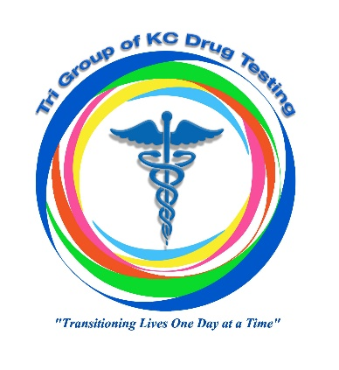
Tri Group of KC Drug Testing
“Transitioning Lives One Day at a Time”

Referral for Drug Testing Services
Agency:
Case Manager |  | County |  |  | Account Number
Received Results by (select one)  - Email  - Fax |  | Email Address |  |  | Fax Number |  |  | Phone Number
CLIENT BEING REFERRED:
Name: |  |  | - Male | - Female |  | Date of Birth | DCN |  |  | Phone Number
Address:
SERVICE PROVIDER INSTURCTIONS:
Collection Location: | - Clinic  - Mobile Collection Unit  - Other_______________________________
Service Requested:  (Please check and circle)  - One Time  - Weekly  - Biweekly  - Monthly  - Bimonthly  - Quarterly | - 5-Panel Drug Screen Urine Hair  - 9-Panel Drug Screen Urine Hair  - 10-Panel Drug Screen Urine Hair  - 11-Panel Drug Screen Urine Hair  - Alcohol Urine  - Medical Review Officer Test  - Positive Confirmation  - ETG Breathalyzer  - Oral Fluid Test
SIGNATURES:
Case Manager Signature |  |  |  |  |  |  |  |  | Date
***CLINIC USE ONLY***
Acceptable Forms of ID for Testing:

- Driver’s License issued by State, with a photograph; or
- Photo identification card issued by federal, state, or local government

____Test was completed on _____/_____/_____
____Donor did not arrive for testing by assigned date.
____Donor refused testing on _____/______/______
____Donor did not have photo ID and test could not be performed on ____/_____/_____
____Other: _________________________________________________________________

Signature of Collector_____________________________________________________

Please complete and email or fax to: drugtesting@trigroupofkc.org or (866)264-9446

